**Homework 2**

* Type of key points that you detected in the images

SIFT: https://docs.opencv.org/3.1.0/da/df5/tutorial_py_sift_intro.html

SURF

When I use the sift, I found the query_17 key points only have 11 by SIFT. Therefore, I SURF when I cannot find key points=30

* Hyper-parameters of the CNN architecture for computing feature descriptors

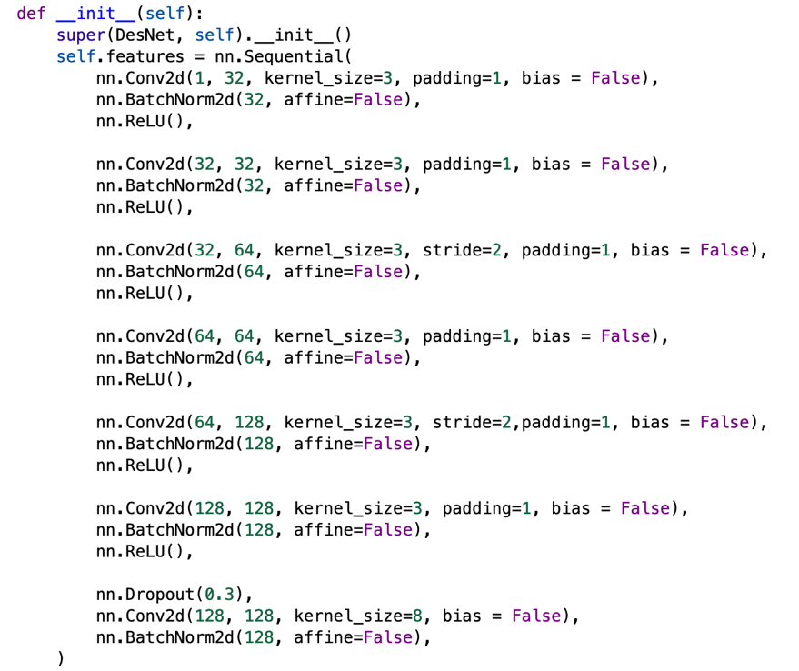

* Two recall-precision curves of image retrieval, where each curve uses the corresponding results

